**Lab 6: Configuring DNS Server**

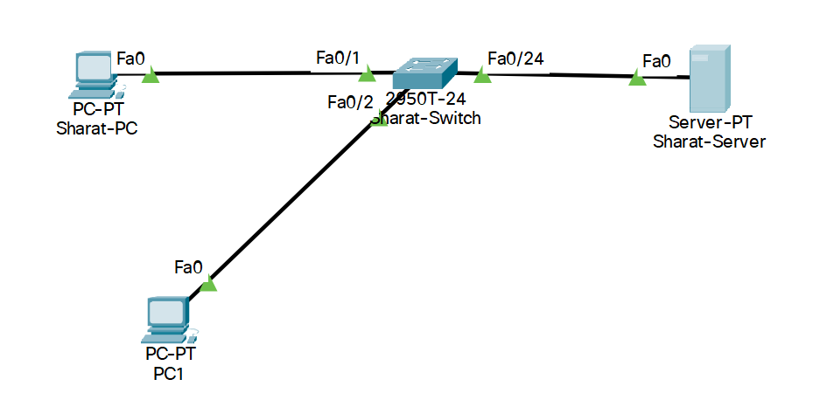

|  |  |  |
| --- | --- | --- |
| Device | IPv4 Address | Subnet Mask |
| Sharat-PC | 192.168.1.2 | 255.255.255.0 |
| PC1 | 192.168.1.3 | 255.255.255.0 |
| Sharat-Server | 192.168.1.1 | 255.255.255.0 |

* Design the given topology.
* Assign the Layer 3 address to all hosts.
* Turn on and configure DNS Server in Sharat-Server.
* Add primecollege.com for IPv4 192.168.1.1 in DNS Server.
* Access primecollege.com and 192.168.1.1 from Sharat-PC and PC1.

**Lab 7: Configuring DHCP Server**

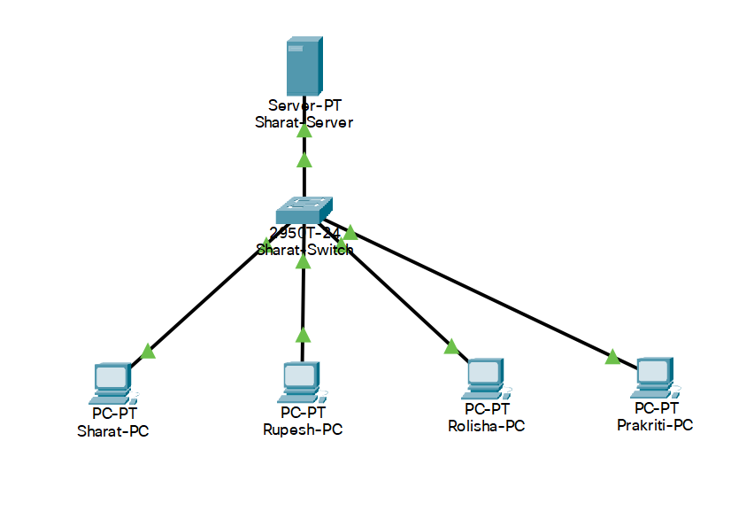

|  |  |  |
| --- | --- | --- |
| Device | IPv4 Address | Subnet Mask |
| Sharat-PC | Obtained from DHCP Server | Depends on IPv4 class |
| Rupesh-PC | Obtained from DHCP Server | Depends on IPv4 class |
| Rolisha-PC | Obtained from DHCP Server | Depends on IPv4 class |
| Prakriti-PC | Obtained from DHCP Server | Depends on IPv4 class |
| Sharat-Server | 192.168.1.1 | 255.255.255.0 |

* Design the given topology.
* Assign the Layer 3 address to all hosts.
* Turn on and configure DHCP Server in Sharat-Server.
* Obtain IPv4 address from DHCP Server on all the hosts dynamically.